Student Name |  |  |  |  | Student Id Number |  |  | Signature
Mirza Muhammad Bin Munshee |  |  |  |  | 82669 |  |  | 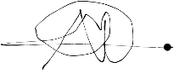
Javier Miguel Abeng |  |  |  |  | 84110 |  |  | 
Robbie Samir Anak Bruno |  |  |  |  | 85556 |  |  | 
Azeleen Jane Romanus |  |  |  |  | 83340 |  |  | 
Christine Yong Sze Teng |  | Christine S |  |  | 82491 |  |  | 
Subject Code/Name: | TMA3084 SOFTWARE ENGINEERING LAB |  |  |  |  |  | GROUP #: |  | 17
Assignment Title: |  | Project Proposal |  | Lecturer: |  | Mdm. Nurfauza Jali
Project Title: Wedding2U

This cover sheet must be completed, signed and firmly attached to the front of the submission. All work must be submitted by the due date. If an extension of work is granted, an assignment extension acknowledgement slip must be signed by the lecturer/tutor and attached to assignment. Please note that is your responsibility to retain copies of your assignment

Plagiarism and Collusion are methods of cheating that falls under Peraturan Akademik Universiti Malaysia Sarawak para 11: Etika Akademik

Plagiarism

Plagiarism is the presentation of work which has been copied in whole or in part from another person’s work, or from any othe r source such as the internet, published books or periodicals without due acknowledgement given in the text.

Collusion

Collusion is the presentation of work that is the result in whole or in part of unauthorised collaboration with another person or persons.

Where there are reasonable grounds for believing that cheating has occurred, the only action that may be taken when plagiarism or collusion is detected is for the staff member not to mark the item of work and to report or refer the matter to the Dean. This may result in work being disallowed and given a fail grade or if the circumstances warrant, the matter may be referred to a Committee of inquiry for investigation. Such investigation may result in the matter being referred to the University Discipline Committee, which has the power to exclude a student.

Upon placing signature above, I certify that I have not plagiarised the work of others or participated in unauthorised collusion when preparing this assignment.

I also certify that I have taken proper case in safeguarding my work and have made all reasonable efforts to ensure that may work not be able to be copied.

Comments: Make the recommended adjustments according to the feedback given. Excellent work—your team can now proceed.

The Proposal of Wedding Planner Mobile Application (Wedding2U)

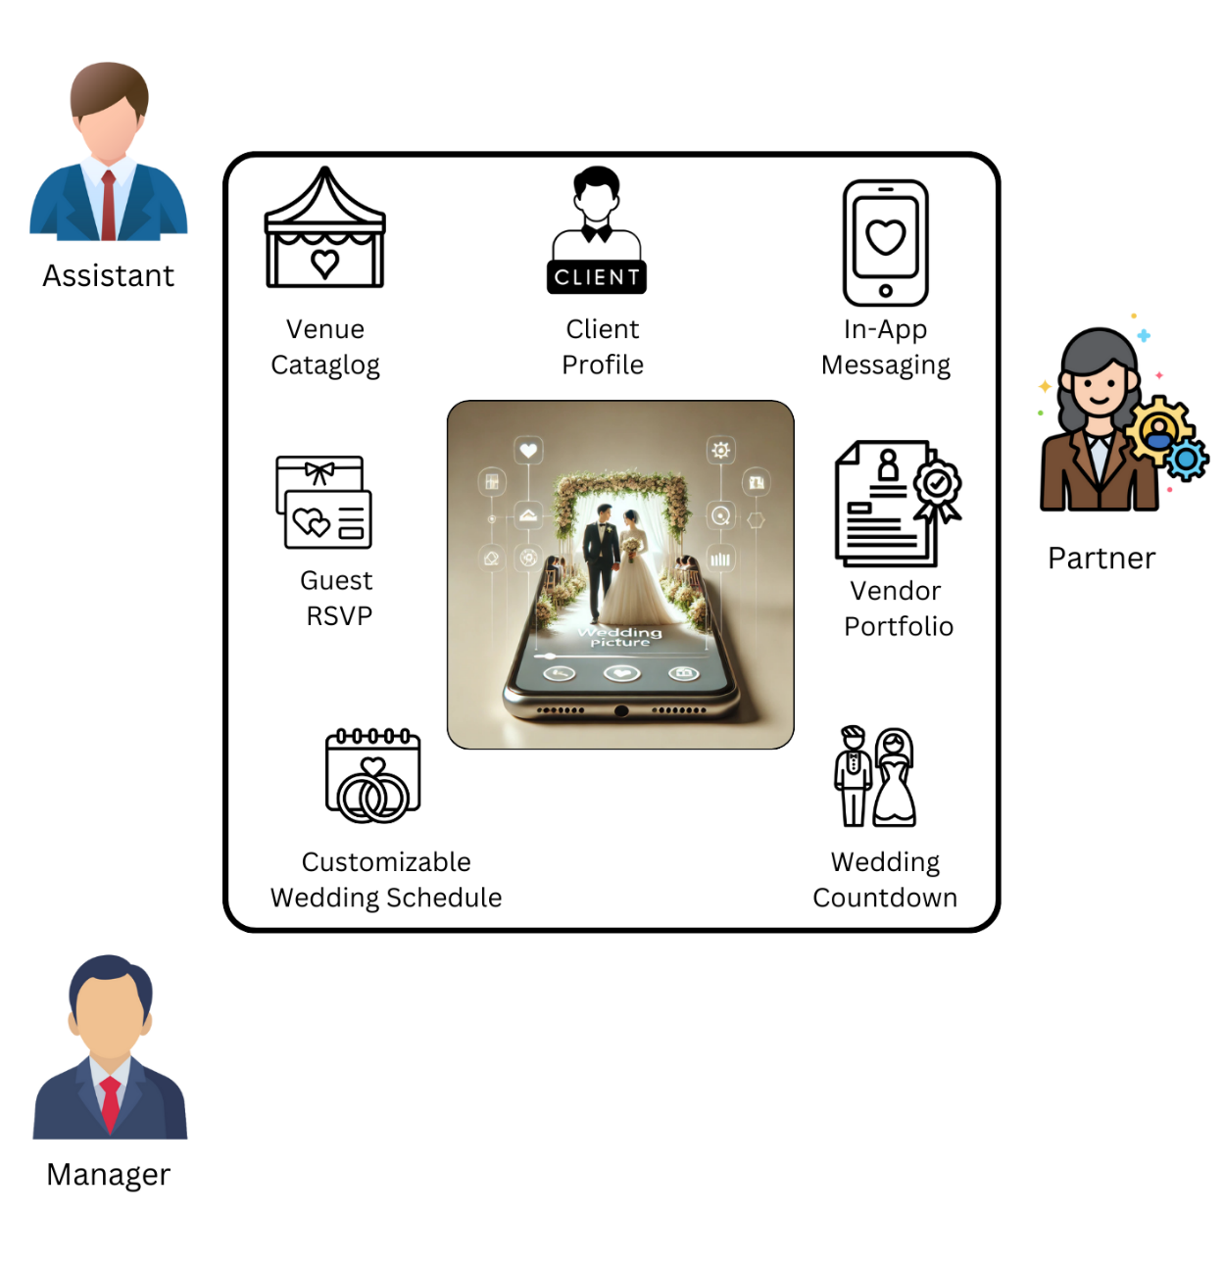

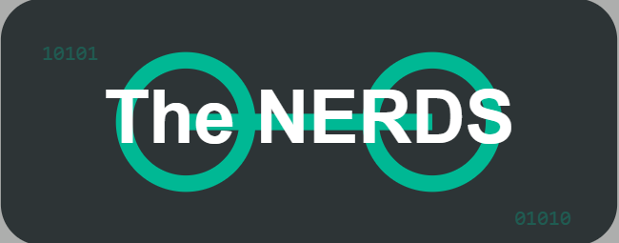 | 

Table of Content
Abstract i
1. Introduction 1
1.1 Company Background 1
1.2 Team Background 2
2. Problem statement 4
3. Project Objectives 4
4. Project Perspective 5
5. Project Scope 7
5.1 System Environment 8
5.2 System Functionality 10
6. Software Methodology 16
7. Task Allocation & contribution 19
8. Team Goals 20
9. Expected Result / Deliverables 21
9.1 Working System 21
9.2 System Artefacts/Documentation 21
10. Project planning 23
11. References 25

List of Figure
Figure 1: The Nerds and Wedding Project first meeting 2
Figure 2: Wedding Project Logo 2
Figure 3: Group photo of The Nerds 3
Figure 4: Logo for The Nerds 3
Figure 5: 3-tier architecture for Wedding Planer mobile app 5
Figure 6: System Modules for Wedding Planner Mobile Application Project 11
Figure 7: The Scrum Framework (2020) 17
Figure 8: Gantt Chart 25

List of Table
Table 1: System environment specification required for development. 8
Table 2: System Functionality List 12
Table 3: Task Allocation & Contribution List 19
Table 4: Description of System Artefacts/Documentation Involved 22
Table 5: Project Planning Schedule 24

Abstract

In the current digital age, the wedding planning sector must adapt to the contemporary needs of convenience, organisation, and personalisation. Our client has assigned us the task of developing a comprehensive wedding planner application, which is seen as potentially the first of its kind in Sarawak due to the increasing demand for a structured and efficient approach to planning weddings. Our team, known as Nerds, consisting of dedicated Software Engineering students, is committed to creating a solution that makes wedding planning easier for both customers and suppliers. Nowadays, wedding planning has traditionally required a lot of effort, with a strong emphasis on face-to-face meetings and hands on organisations. This traditional method frequently leads to misunderstandings in communication, clashes in schedules, and more pressure for couples during a critical moment in their lives. By consulting with experts in the field, we have gathered important information on the key elements necessary to simplify and improve the planning procedure. We aim to create a platform that is easy for users, allowing them to schedule appointments and manage vendors, while also giving them the ability to customise and control all aspects of their event. Nerds provides an innovative application that perfectly meets the needs and desires of wedding planners and couples in Sarawak by including these advanced features.

Introduction
Efficient organisation of wedding planning tasks is essential for a seamless experience for both clients and vendors. Wedding2U, a wedding planning service based in Sarawak, faces unique challenges in managing client interactions and coordinating vendor services due to its reliance on traditional, in-person methods. Our client has emphasised the need for a streamlined approach that retains the personal touch of direct interactions while introducing digital efficiency to support growing demands. Additionally, the app will cater exclusively to Wedding2U’s management team, who primarily use desktop devices in an office setting.
Our solution, a web-based application named Wedding2U, is designed to enhance operational flow, allowing the team to handle client appointments, vendor communications, and event schedules in a single, organised platform. This digital innovation aims to reduce scheduling conflicts and improve communication, aligning with the company’s goals of delivering high-quality, personalised wedding experiences. By integrating both traditional service values and modern technology, Wedding2U represents a dedicated effort to elevate customer satisfaction and enhance Wedding2U’s reputation as a leading provider of wedding planning services in Sarawak.

1.1 Company Background
The business, Wedding Project, was founded in 2010 and is based in Kuching's Petra Jaya. The manager of the wedding project is our client, Madam Sarina Ahmad, who is also known as Madam Eina. Wedding Project is a wedding management organisation that offers services like food catering, grooming, and wedding venues. The goal is to develop a mobile application for managing existing and future wedding appointments that is mode led like an appointment scheduler.

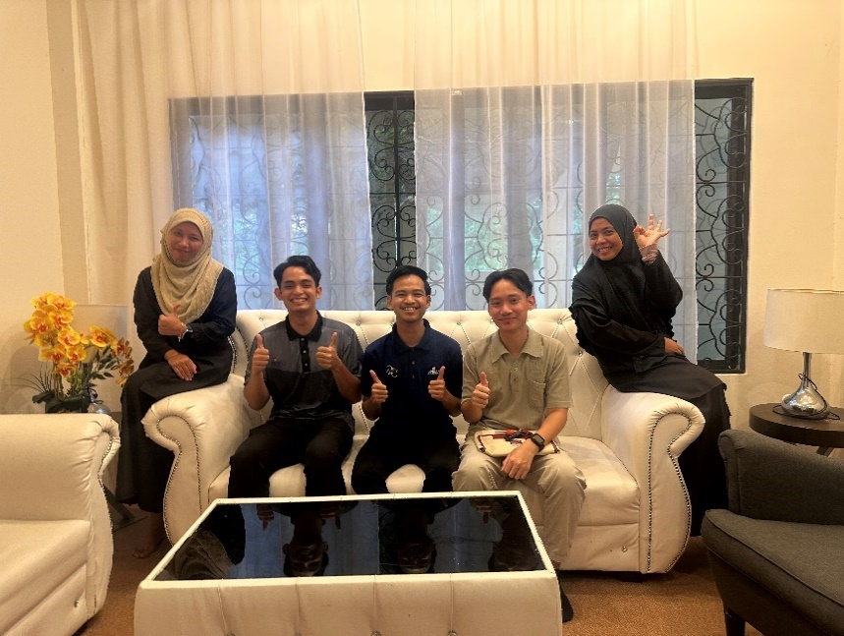
Figure 1: The Nerds and Wedding Project first meeting
Figure 2: Wedding Project Logo

1.2 Team Background
Five committed individuals make up our team, The Nerds, and each one contributes special talents and abilities to the project. With the help of Javier Miguel Abeng, Robbie Samir Anak Bruno, Christine Yong Sze Teng, and Azeleen Jane Romanus, the team is led by Mirza Muhammad bin Munshee. October 2024 saw the founding of the Nerds. We ensure that assignments are assigned fairly, utilising each team member's unique abilities to successfully accomplish our objectives. Our team was established to create a creative solution for Wedding2U under the direction of Madam Nurfauza Jali's experience, with the goal of producing a superior digital product that satisfies our client's requirements. We're determined to do everything in our power to make this initiative a success.

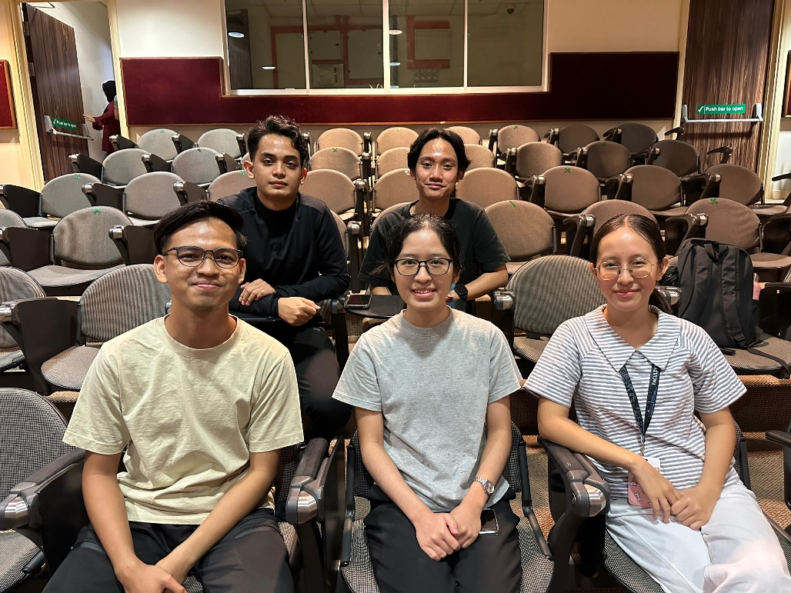
Figure 3: Group photo of The Nerds
Figure 4: Logo for The Nerds

Problem statement
In order to determine the difficulties facing her organisation, Madam Eina, the manager of Wedding Project, a wedding management company, was interviewed. According to the data acquired, Wedding Project uses Microsoft Excel as a manual appointment keeping method. Even though the program efficiently records the client's appointment information, Madam Eina and her team find it challenging to constantly update the Excel sheets. This can make it more difficult to remember staff responsibilities and appointments. In addition, clients who need to make modifications to their wedding reservation must speak with Madam Eina and her staff, as this would necessitate further care. Additionally, the availability of booking services will be manually updated and communicated to clients upon request.
It is decided to create a mobile application to help Wedding Project and its clients, based on most of the difficulties encountered. The app will show all the features and information required to customise wedding reservations to the preferences of the users. To make it easier for guests to confirm their attendance, an RSVP option will also be implemented.

Project Objectives
- To study and analyse the existing system problem and identify solutions to enhance the overall planning process
  - This objective focuses on understanding the limitations and inefficiencies in current wedding planning methods to develop a tailored solution that meets the needs of both owners and clients.
- To design and develop the mobile app based on client’s requirement
  - This objective involves creating a well-structured design and developing the app with features that streamline planning tasks, improve user interaction, and offer personalised assistance for clients.
- To test and evaluate the mobile app to ensure functionality, usability, and reliability
  - This objective emphasises conducting thorough testing to identify potential issues and gathering feedback to refine the app, ensuring it meets quality standards and user expectations.

Project Perspective
The primary objective of our project is to develop a comprehensive mobile application that transforms the wedding planning process, leading to enhanced operational efficiency and improved user experience for couples and vendors alike. By implementing this innovative solution, we aim to elevate customer satisfaction, providing a seamless and engaging platform for managing wedding details.
A 3-tier architecture is chosen for the wedding planner mobile app, consisting of the presentation, application and the data layer.
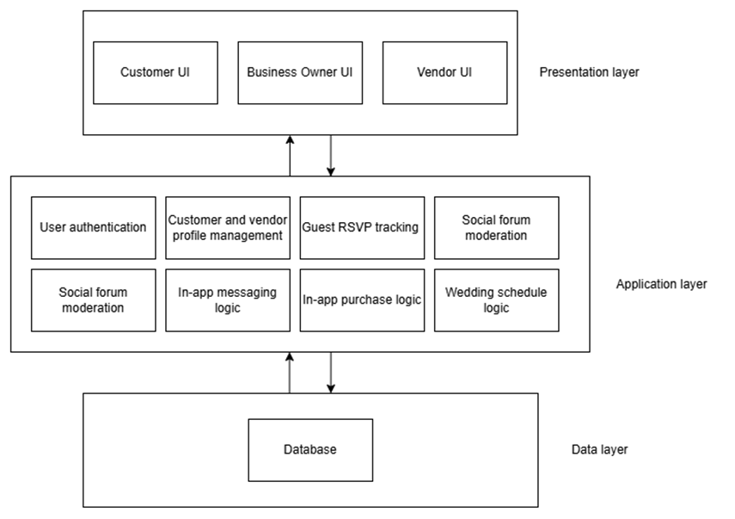
Figure 5: 3-tier architecture for Wedding Planer mobile app
The presentation layer provides the user interface tailored for each user types (customer, business owner, vendor). The user interface contains 9 key features, which are the venue package catalog, customer profile, guest list and RSVP, customer social forum, vendor portfolio, in-app purchase for vendor service, vendor-client in-app messaging, customisable wedding tentative and wedding countdown.
The application layer contains the business logic that help accomplishes the app’s core features. Key modules in the application layer comprises of:
- User authentication: Control app access based on user type (business owner, customer, vendor) and allowing or restricting feature access accordingly.
- Business logic for each feature:
- Catalog management: Manage CRUD operations for venue packages
- Customer and vendor profile management: Handles customer and vendor profile information updates and privacy settings
- Guest RSVP tracking: Manage the live tracking of guest RSVP
- Social forum moderation: Manage customer posts and comments, enforcing forum guidelines
- In-app messaging logic: Handle messaging process between customers and vendors
- In-app purchase processing: Handles customers transactions for vendor services to ensure secure payments and transaction tracking.
- Wedding scheduling logic: Handle the customisation of wedding tentatives and wedding countdowns
Lastly, the data layer contains the database to store essential data, including user profiles, venue packages, vendor portfolios, social forum posts, messages, wedding event timelines, and transaction records.
One major reason for using a 3-tier architecture is that it enables modularity by separating features into distinct modules. This allows for easy integration of new features and maintenance of existing features. The layered architecture also enables effective and streamlined team collaboration by allowing team members to specialise in different tiers such as the front-end, back-end and database during app development (Chiaramonte, 2024). Moreover, it improves security by preventing direct access of end users to the database, and allows for the enforcement of safety measures between each layer to offer multi-layered protection against security issues. Lastly, the architecture allows for the iterative development of app features, which supports the Agile principle of incremental delivery.

Project Scope

The goal of the Wedding Planner app is to streamline the planning process for couples and vendors in Sarawak by providing a personalised digital solution. Created by our team, Nerds, this mobile application is designed to act as a comprehensive platform for organising all aspects of wedding celebrations, improving the planning process, and facilitating smooth communication between customers and vendors. This app will enhance customer interaction, streamline planning duties, and offer a more efficient method for overseeing weddings.
This Wedding Planner app includes important features like a venue catalogue that displays a list of potential venues with images, reviews, and essential information. Clients will be able to create personal profiles to keep essential information and connect social media accounts to share their planning process. The application will also include a section for users to display their posts and provide reviews and engage with loved ones. Moreover, users can purchase a comprehensive checklist within the app to assist in monitoring their progress in every phase of the planning process.
In order to enhance the experience, a live guest RSVP feature enables users to monitor guest responses instantly. The app will also feature a personalised wedding day tentative, allowing couples to see and share a schedule of their activities. A countdown feature for the wedding ceremony will maintain excitement levels, displaying the remaining time until the special day. Additionally, the in-app messaging feature facilities direct communication between clients and vendors, resulting in seamless interaction. Vendors will be able to showcase their services in a dedicated portfolio section, including images and short biographies, to assist clients in making well-informed choices.
The Wedding Planner app prioritises data security, ensuring the protection and confidentiality of all user information. Our team, Nerds, provides a high-quality wedding planning experience in Sarawak by utilising these features, creating a practical and enjoyable solution for both clients and vendors.

5.1 System Environment
Table 1: System environment specification required for development.
This configuration ensures seamless use of the application by both the development team and end users.
Environment | Software | Hardware | System Requirements
Development | Operating System – Windows 11 | Personal Computers (PCs), Mobile Devices | Reliable Internet Access
 | Source Code Editors – Visual Code, Android Studio | Laptop
 | Emulator Software for Android and iOS
 | Graphics Editors – Adobe XD, Photoshop 2021, Canva, Adobe Illustrator 2019
 | Web Hosting for Backend APIs – Firebase, AWS
 | Local Hosting – XAMPP Server for Backend Testing
Delivered | Mobile Platforms – Android OS, iOS | Mobile Devices (Smartphones/ Tablets) | Devices running Android (v9 and above), iOS (v12+)
 | Messaging Service – Twilio, Firebase Cloud Messaging (FCM)
 | Email Integration – Google Mail App, Outlook

Using languages and tools fit for mobile development, the Mobile Application for Wedding Planner will be developed to ensure a strong, user-friendly design and performance. Well-known development tools help our team to make effective debugging and testing using great resources. Main programming languages and frameworks are:
- Flutter (for cross-platform mobile app development)
- Dart (programming language for Flutter development)
This chosen development environment is intended to build a secure, responsive, and interactive wedding planner application that eases the planning process and provides a seamless experience for users

5.2 System Functionality
Module Name | Description
- User Interface | Primary access point for users, with role-based navigation and alerts
- Venue Catalog | Explore venues with detailed info, images, reviews and ratings
- Customer Profile | Manage profiles and integrate social media for style preferences
- Client Posts & Reviews | Create posts, share moments, and view/leave reviews
- In-App Purchases for Checklists | Purchase and track checklist progression
- Guest RSVP | Send and manage RSVPs with real-time attendee tracking
- Customizable Wedding Tentative | Add event details and display a clear schedule
- Wedding Ceremony Countdown | Countdown timer for the wedding day
- In-App Messaging with Vendors | AI chatbot for FAQs and vendor recommendations
- Vendor Portfolio | Showcase vendor services, pricing and reviews

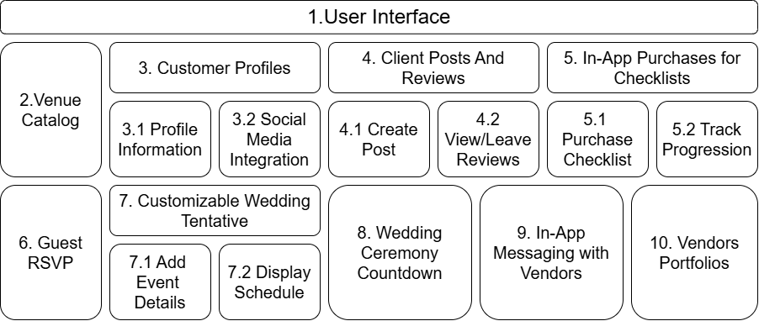
Figure 6: System Modules for Wedding Planner Mobile Application Project

Table 2: System Functionality List
Module |  | Functions | Description
- User Interface |  | Serves as the primary access point for users, such as clients (bride and groom), vendors, and guests. | The User Interface (UI) is made to be user-friendly, providing simple access to all modules. It features navigation components such as a dashboard, menu options, icons, and alerts for new messages or updates. The user interface adjusts according to user roles, displaying suitable choices depending on whether the individual is a client, vendor, or guest.
- Venue Catalog |  | Enables clients to explore and examine in-depth information regarding possible wedding locations. | Display a selected collection of wedding locations, featuring pictures, description, and information about their locations. Every venue features a specific page showcasing customer reviews and ratings, enabling clients to compare choices and bookmark favourites.
- Customer Profile | 3.1 Profile Information | Allows users to create and manage a personal profile in the application. | Contains fields for entering names, wedding date, location, and other personal details. This helps vendors and the app itself to recommend relevant services and options.
- Customer Profile | 3.2 Social Media Integration | Links the client’s social media accounts to the application. | Enables clients to connect social media profiles such as Instagram or Facebook, giving vendors insight into the client’s style choices and character.
- Client Posts and Reviews | 4.1 Create Post | Allows users to create posts and share moments | Provides a QR code for clients and guests to submit images to share the moment.
- Client Posts and Reviews | 4.2 View/Leave Reviews | Enables other users to submit reviews and feedback on posts. | Friends, family, and vendors can provide encouraging remarks or feedback, introducing a community element to the wedding planning process.
- In-App Purchases for Checklists | 5.1 Purchase Checklist | Facilities the in-app purchase of the checklist feature. | Guides users through an easy buying procedure. Following the purchase, the checklist becomes available and can be accessed in the user’s profile.
- In-App Purchases for Checklists | 5.2 Track Progression | Enables clients to denote finished tasks and track advancement. | The checklist serves as a visual cue for task completion, aiding clients in maintaining organisation and staying on track.
- Guest RSVP |  | Enables clients to send and manage RSVPs for their wedding attendees. | Clients have the option to send digital RSVP invitations to attendees, who can reply directly via the app. The application monitors RSVP replies instantly, sorting attendees into “Confirmed”, “Declined”, or “Pending”.
- Customisable Wedding Tentative | 7.1 Add Events Details | Allows clients to include particular information for each occasion on the wedding day. | Clients can indicate event names, starting times, venues, and additional notes for each segment of the day (e.g., ceremony and reception).
- Customisable Wedding Tentative | 7.2 Display Schedule | Presents the wedding-day schedule in a clear and organised format. | The timetable is available to clients, vendors, and visitors, making sure all are aware of the day’s happenings.
- Wedding Ceremony Countdown |  | Shows a countdown timer to the wedding day. | This function counts down in days, hours, and minutes, generating anticipation as the important day nears. It stands out on the dashboard, clearly noticeable right after logging in.
- In-App Messaging with Vendors |  | Offers an interactive FAQ chatbot that allows clients to swiftly obtain answers to typical wedding planning inquiries. | Rather than using direct messages, this module provides an Al-driven chatbot that allows clients to ask questions concerning wedding planning. If a solution is not available, the chatbot may recommend reaching out to support or vendors directly.
- Vendor Portfolio |  | Enables vendors to present their offerings, previous projects, and customer feedback. | Vendors possess specific profile featuring images, descriptions of services, pricing choices, and biographies. Client can explore portfolios to locates vendors that suit their style and budget. Vendor pages include customer reviews to assists clients in making informed decisions

Software Methodology
For our Wedding2U Mobile Application project, we’ve chosen the Agile Scrum Methodology as our foundation. Scrum is a popular agile framework that enables teams to self-organise and work toward a common goal. This approach helps teams tackle complex challenges while maximising productivity and creativity (GeeksforGeeks, 2024). Key advantages of Scrum include reduced risk, enhanced adaptability to changing priorities, improved identification of bottlenecks, increased transparency through frequent delivery of product increments, and the opportunity to inspect and adjust based on ongoing learning (Scrum Alliance, 2021).
In Scrum, there are three key accountabilities that ensure every aspect of the shared work is managed effectively. The developers are professionals on the Scrum team who collaborate to build the product during each sprint, creating increments with their diverse skill sets based on the product’s specific needs. The Product Owner is responsible for defining and prioritising the product goal and backlog, ensuring the team focuses on the highest-value work. Balancing stakeholder, customer, and team needs, the Product Owner brings a deep understanding of the market and customer desires to the role. Finally, the Scrum Master guides the team in adopting Scrum practices and agile principles, helping to remove obstacles and fostering team growth. They coach the team on effectively using Scrum events and artifacts, supporting both individual and collective development (Scrum Alliance, 2021).
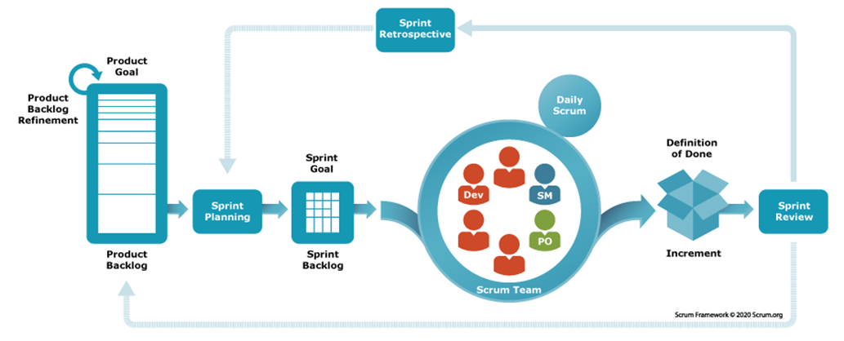
Figure 7: The Scrum Framework (2020)
Scrum artefacts are key tools that help the Scrum team manage projects and address challenges effectively. The three main artefacts in Scrum are the product backlog, sprint backlog and increment. The product backlog contains a dynamic list of requirements, user stories and fixes to be completed to ensure the project’s success. Meanwhile, the sprint backlog is the selection of high-priority items from the product backlog chosen for completion within a sprint. Lastly, the increment is the usable product delivered at the end of the sprint (AWS, n.d.).
The Scrum framework is implemented by delivering customer value incrementally and iteratively within a time-boxed period called sprint, that typically lasts for 1-4 weeks (Hartshorne, 2024). It consists of several scrum events that the team perform regularly:
- Product backlog grooming
The Product Owner will create, maintain and update the list to align with product vision, customer feedback and market demands.
- Sprint planning
Next, a sprint planning meeting is held by the scrum master together with the product owner and development team. The Scrum team sets a sprint goal, determines which product backlog items is feasible to be added to the sprint backlog, and defines criteria for approval and acceptance of the work delivered.
- Sprint execution
Upon reaching a consensus on the sprint goal and backlog, the sprint can be started. The sprint is the actual period where the development team will work together to finish an increment according to the agreed-upon sprint backlog and goal.
- Daily scrum
The scrum master will lead a brief daily stand-up meeting during the sprint period to discuss progress, align the team, and address any roadblocks.
- Sprint review
At the end of the sprint, the sprint review is held, where the team will inspect the demo of the increment and showcase it to the product owner and other stakeholders. The release of the increment will be decided by the product owner, based on criteria agreed-upon by the team during the sprint planning meeting.
- Sprint retrospective
Finally, the sprint retrospective is a session to evaluate on the team performance during the sprint and what needs to be improved for the next time (Atlassian, n.d.)
This cycle of planning, development, and review repeats until the project reaches completion, delivering customer value incrementally and ensuring adaptability to changes along the way.

Task Allocation & contribution
Table 3: Task Allocation & Contribution List
Team Members | Roles, Tasks and Responsibilities
Mirza Muhammad Bin Munshee | Project Manager  - In charge of the project team.  - Work together with the project boss to plan the work.  - Keep an eye on how the project is going.  - Taking care of project risks.  - Tell the client how the job is going.  - Getting the client's needs for the web service together.
Christine Yong Sze Teng | Development Manager  - In charge of the technical implementation of the app.  - Coordinates daily development tasks, ensuring alignment with the sprint goals and priorities set in the sprint backlog.  - Works with the Quality Manager to ensure all code meets quality standards before it’s integrated.  - Manages version control, merging, and deployment processes to maintain a smooth development workflow.  - Provides support to developers, addresses technical challenges, and reviews code to maintain consistency.
Javier Miguel Abeng | Planning Manager  - Develops the project's overall strategies and processes.  - Oversees all processes to ensure they align with the project schedule.  - Collaborates with the project manager to coordinate the project plan.
Robbie Samir Anak Bruno | Quality Manager  - Assesses the coding, interface, and functionality of the mobile application.  - Organise, execute, and monitor the assessments and evaluations of mobile application to ensure its quality.  - Work closely with developers, product managers, and stakeholders to align on quality expectations, communicate test results, and ensure timely resolution of issues.
Azeleen Jane Romanus | Support Manager  - Keep detailed records of support activities, monitor app performance and ensure the app meets quality standards before and after deployment.  - Ensure timely resolution of technical issues, coordinate updates, and maintain app’s performance to meet client expectations.  - Collect feedback from client to refine the app based on their needs.

Team Goals
  - Give Wedding2U an easy-to-use mobile app that meets their basic needs and improves their online profile and accessibility.
  - Keep detailed records of the project's design, development, and testing stages so that they can be reviewed and updated in the future.
  - Work well with others to learn how to use agile development methods like scrums and sprints in real life.
  - Make sure that project deadlines and quality standards are followed, meeting all client goals for quick and effective delivery.

Expected Result / Deliverables

9.1 Working System
We aim to conclude our project by giving Wedding2U a mobile app that is easy for users to use and helps them handle their guests. This app will have a catalogue of venues with full descriptions and reviews to help users choose. Clients and guests will be able to customise and connect with each other through profiles that include tracking of RSVPs, a wedding countdown, and a wedding day schedule that can be changed. You can buy a thorough checklist inside the app, which will help you plan your milestones in a more organised way. All these features will make planning a wedding easier, giving Wedding2U's customers a smooth and enjoyable experience.

9.2 System Artefacts/Documentation
Table 4: Description of System Artefacts/Documentation Involved
Documentation | Description
- Project Proposal | Explains the project overview, objectives, and scope, providing a clear proposal to both the client (Wedding2U) and project supervisor during presentations.
- User Manual | Offers step-by-step guidance to testers, clients, and end-users on how to use the app’s key features, such as RSVP tracking, the customisable checklist, and the countdown timer. It also serves as a reference for those managing quality and usability.
- System Requirements Specification (SRS) | A detailed explanation of the app's necessary features and functionalities, covering both what the app should do (functional requirements) and additional standards it must meet (non-functional requirements).
- System Design Specification (SDS) | Describes the app’s structural layout, including the design of main modules and interactions. This document also includes a high-level view of project scheduling and resources, which will guide the development team in constructing the app.
- TSPi Forms | Project tracking forms that help each team member stay on schedule and manage resources effectively. These forms log time, document progress, and record issues, keeping everyone on track and informed.
- Minute Meetings | Records details of discussions and decisions made in team meetings, helping everyone stay updated on project status and action items.
- Test Cases | Lists tests for each feature to ensure they work as required. For example, test cases will verify RSVP tracking, the countdown timer, and the venue catalog functionality, helping identify any issues early.

Project planning
Table 5: Project Planning Schedule
No. | Task | Start Date | End Date | Duration (Days)
1.0 | Planning and Analysis | 14/10/2024 | 28/10/2024 | 15
 | Identify client | 14/10/2024 | 19/10/2024 | 6
 | Interview and gather information from client | 26/10/2024 | 26/10/2024 | 1
 | Review mobile app requirements | 28/10/2024 | 30/10/2024 | 3
 | Project Proposal Documentation | 30/10/2024 | 6/11/2024 | 10
 | Evaluation of project proposal | 7/11/2024 | 8/11/2024 | 2
2.0 | Design and Development | 12/11/2024 | 28/12/2023 | 46
 | Define mobile app architecture | 12/11/2024 | 16/11/2024 | 5
 | UI/UX Design | 17/11/2024 | 25/11/2024 | 9
 | Front-end Development | 26/11/2024 | 5/12/2024 | 10
 | Back-end Development | 5/12/2024 | 15/12/2024 | 10
3.0 | Testing and Deployment | 15/12/2024 | 20/12/2024 | 16
 | Unit Testing and Debugging | 15/12/2024 | 21/12/2024 | 7
 | User Acceptance Testing | 21/12/2024 | 26/12/2024 | 6
 | Final Adjustments and Optimisation | 37/12/2024 | 29/12/2024 | 3
 | Deployment to App Stores | 30/12/2024 | 30/12/2024 | 1
4.0 | Documentation and Project Closure | 31/12/2024 | 04/01/2025 | 5
 | Final Project Documentation | 31/12/2024 | 03/01/2025 | 4
 | Project Review and Closure | 04/01/2025 | 04/01/2025 | 1
Total days | 83

Wedding Planner Mobile Application Project Gantt Chart
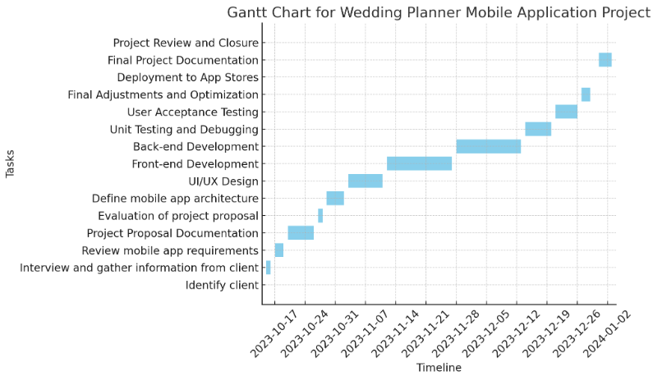
Figure 8: Gantt Chart

References

Atlassian. (n.d.). What is scrum and how to get started. https://www.atlassian.com/agile/scrum

What is Scrum? - Scrum Methodology Explained - AWS. (n.d.). Amazon Web Services, Inc. https://aws.amazon.com/what-is/scrum/

Chiaramonte, M. (2024, November 7). Understanding the architecture of a 3-tier application. vFunction. https://vfunction.com/blog/3-tier-application/

GeeksforGeeks. (2024, June 15). What is Scrum? Understanding the Agile Framework for Project Management. GeeksforGeeks. https://www.geeksforgeeks.org/what-is-scrum/

monday.com Blog. (2024, September 23). Scrum methodology: how to get started in your next project. https://monday.com/blog/rnd/scrum/

What is scrum | Guide to the most popular agile framework. (n.d.). https://www.scrumalliance.org/about-scrum

